Rule: Support Internal Locus of Control
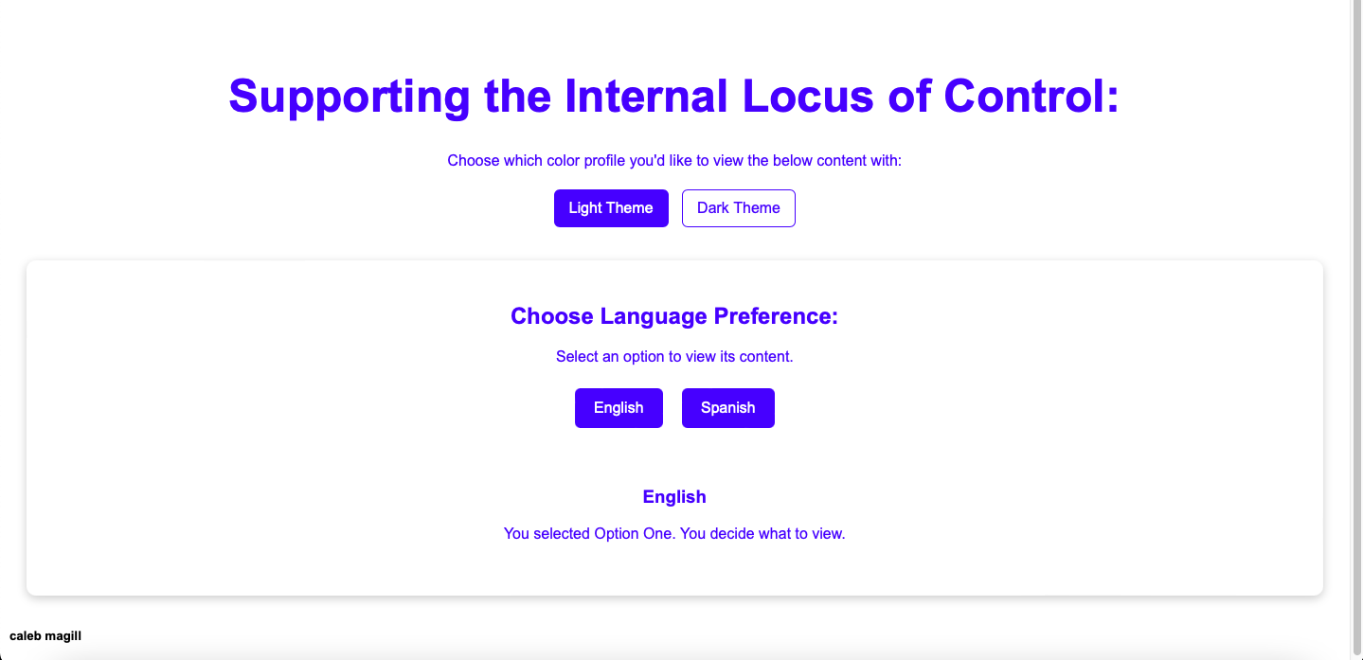
For this page, the user is meant to select their language preference to view the below content. In an attempt to support the user’s internal locus of control, as much autonomy and power is given to the user in regard to how said application’s content is displayed. Said locus of control is provably supported as, upon the user selecting their preference; for either the language or the theme to display it in, the content adapts to support the user’s choice. The consistency of design is another feature that helps the user in transitioning from a previous page (the short-term memory load). The dialogue provided clearly communicates the nature of the options the user is presented with. Lastly, the implicit informative feedback; in the form of the appearance of the content changing, on clicking an option further conveys the actions the user has taken, and if they choose, can easily revert their choice.

